Brazilian E-Commerce Public Dataset – Anaysis Notes

**ORDER ANAYSIS**

**1. Analyze order dsitrubition based on months.**.

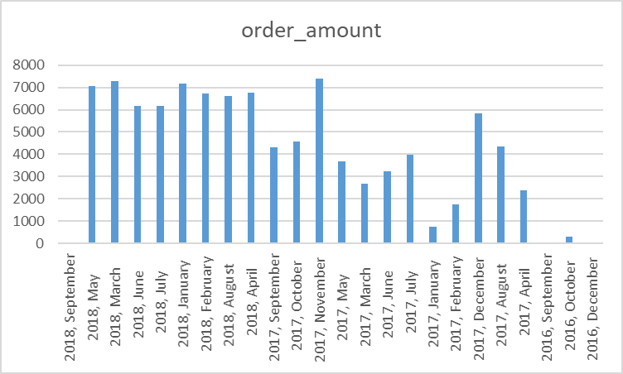

*Orders per Month*

**Comment:** Especially in September-December 2016 and September 2018, the number of orders is almost non-existent. The maximum order was realized in the first half of 2018 and November 2017. There is a somewhat more homogeneous order density on other dates..

**2. Analyze order amount based on order status and months.**

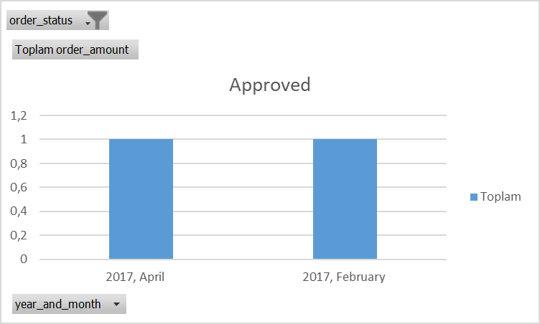 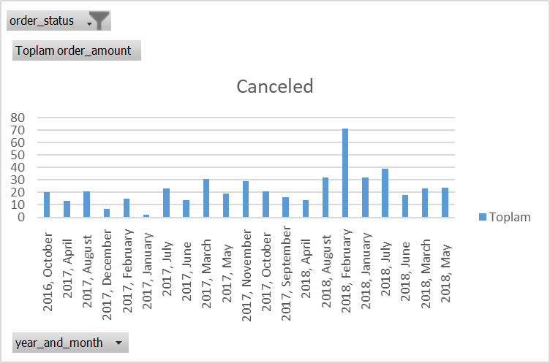

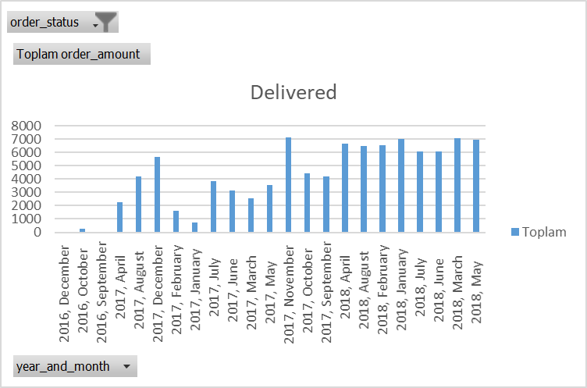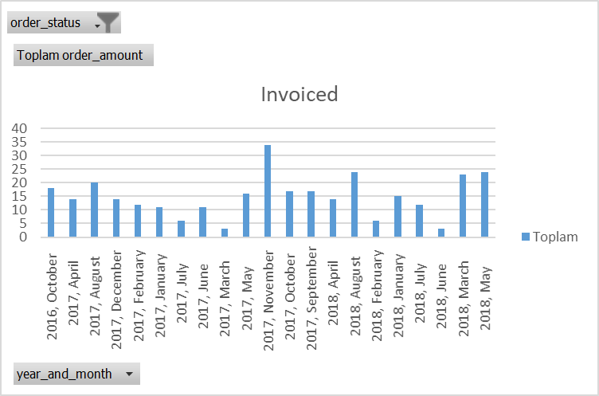

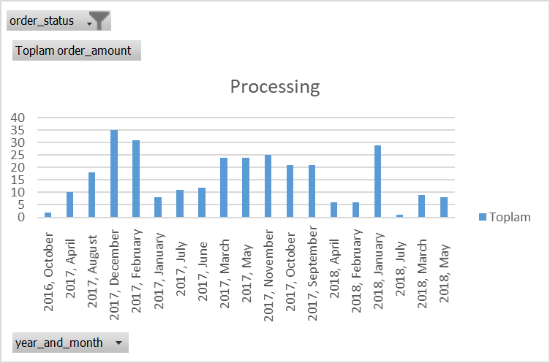 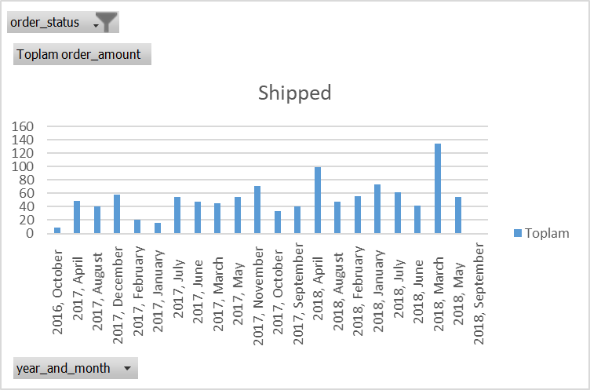

**Comment:** When we examine the orders in terms of status, there is a serious cancellation situation in February 2018.

In 2018, a higher number of product deliveries were made compared to other years. Since 2018 is the last year in the analyzed years, the company may have taken performance improvement actions based on previous years' data and may be benefiting from this.

Although there appears to be a relatively homogeneous distribution in terms of invoicing, it reached its maximum in November 2017. Campaigns such as Black Friday and November discounts may be the reason for the increase in the order amount in November. Invoicing remained at a minimum in June 2018 and March 2017. More data is needed to interpret this decrease.

The number of times the order status "in process" is displayed varies with each passing month. This shows that the company's order processing process is dynamic and orders are received and shipped quickly. However, the maximum transaction is seen in the year-end-new year (new year) period of both 2018 and 2017.

Although the number of products shipped remained relatively the same average throughout the year, a dramatic increase was observed in March and April 2018.

**3.Analze order amounts based on category. Which categories do stand out?**

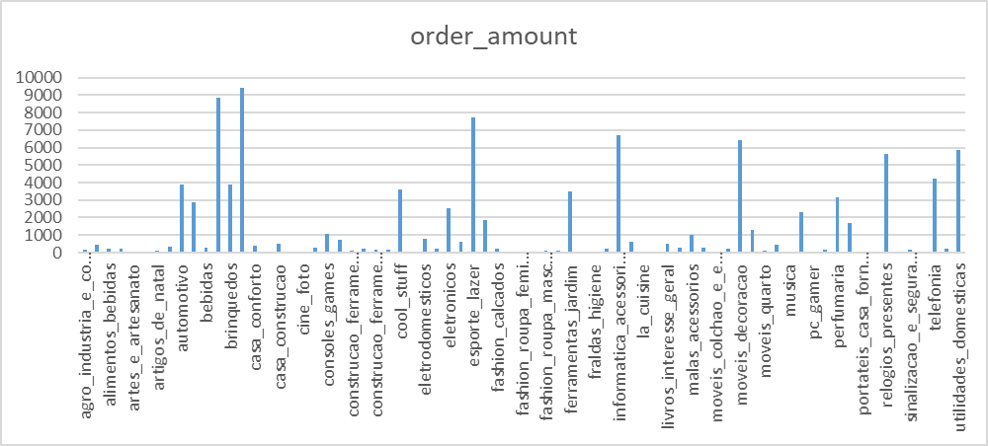

*Orders per Category*

**Comment:** The most ordered product categories are; home decoration, personal care, accessories and electronic devices. The least ordered product categories are; softer categories such as insurance, fashion, hobbies and entertainment.

*For important days*

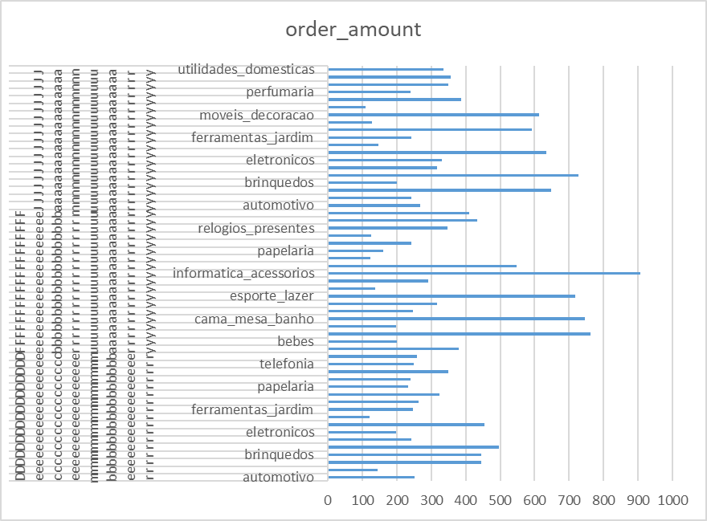

**Comment:** Since the end of the year and the beginning of the year mostly include special days around the world (New Year's Eve, Valentine's Day), the months of December, January and February were analyzed. As can be seen in the graph showing the data of these 3 months, it can be purchased as a souvenir; Electronics, toys and decoration categories were mostly preferred.

**4.Anayze order amounts based on week days and month days**..

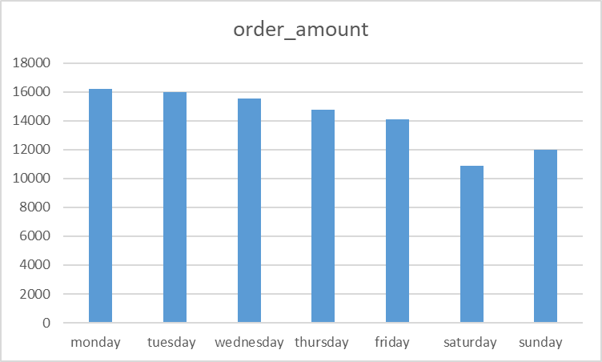**Comment:** When the order quantities are examined according to the days of the week in the chart, more orders are placed during the week. The fact that weekdays are usually the busiest and most stressful times of workdays may lead people to order on the fly.

*Orders per Week Days*

Minimum orders are placed on weekends. This may be because the weekend is a holiday and people spend more social time and move away from the digital environment.

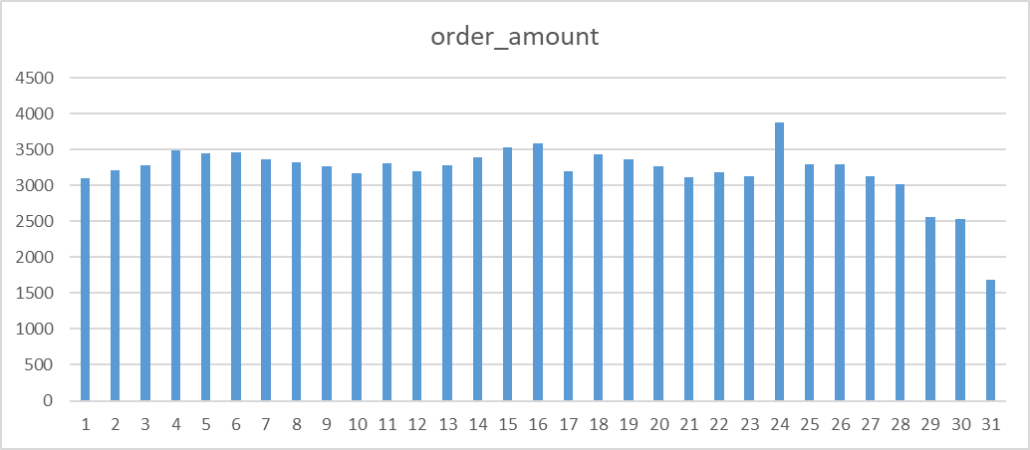

**Comment:** When examined in terms of month days, there is a significant increase in the number of orders on the 24th of the month and a decrease is observed towards the end of the month. This may be due to paydays in Brazil. At the end of the month, as expected, the decrease in people's budget reduces their tendency to shop.

*Orders per Month Days*

#### **CUSTOMER ANALYSIS**

**1. In which cities do customers shop more?**

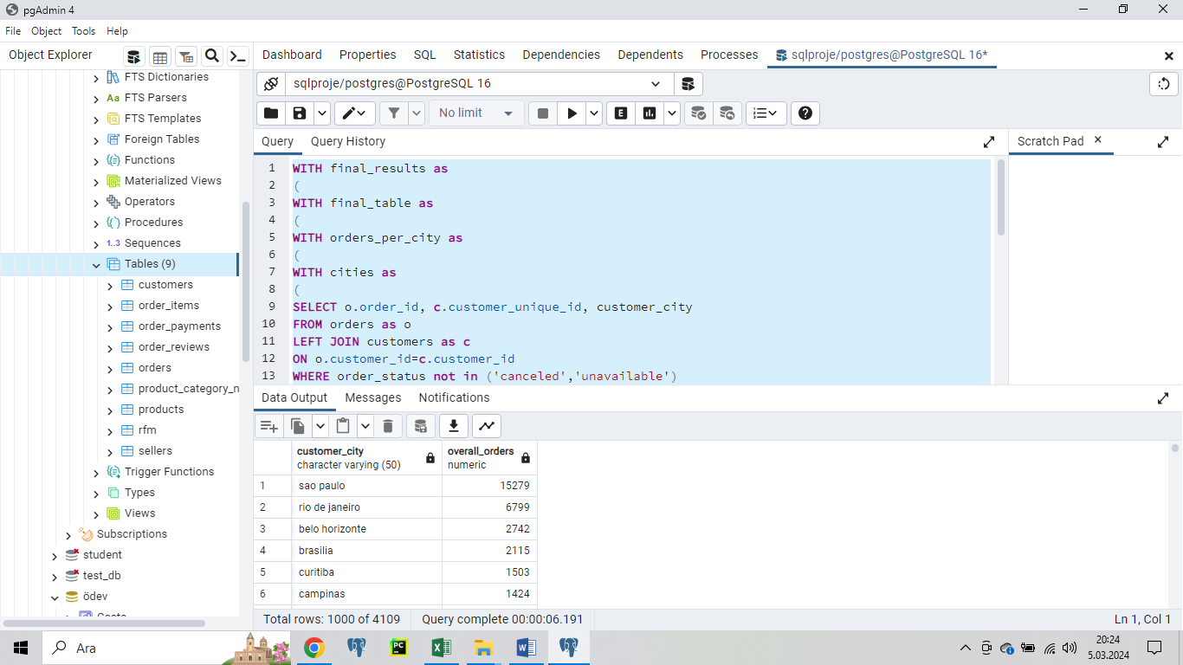

**Comment:** As a result of the query, it is seen that customers living in big cities such as Sao Paulo and Rio de Janeiro are the people who shop the most.

##### **SELLER ANALSIS**

**1. Analyze fastes sellers. (Sellers with more than 10 orders were evaluated)**



**Comment:** The top 5 fastest sellers are listed in the table. There are also sellers who only have 1-2 sales and deliver faster. But this does not mean that it is a high performer compared to sellers who sell much more. Therefore, sellers who made at least 10 sales were evaluated..

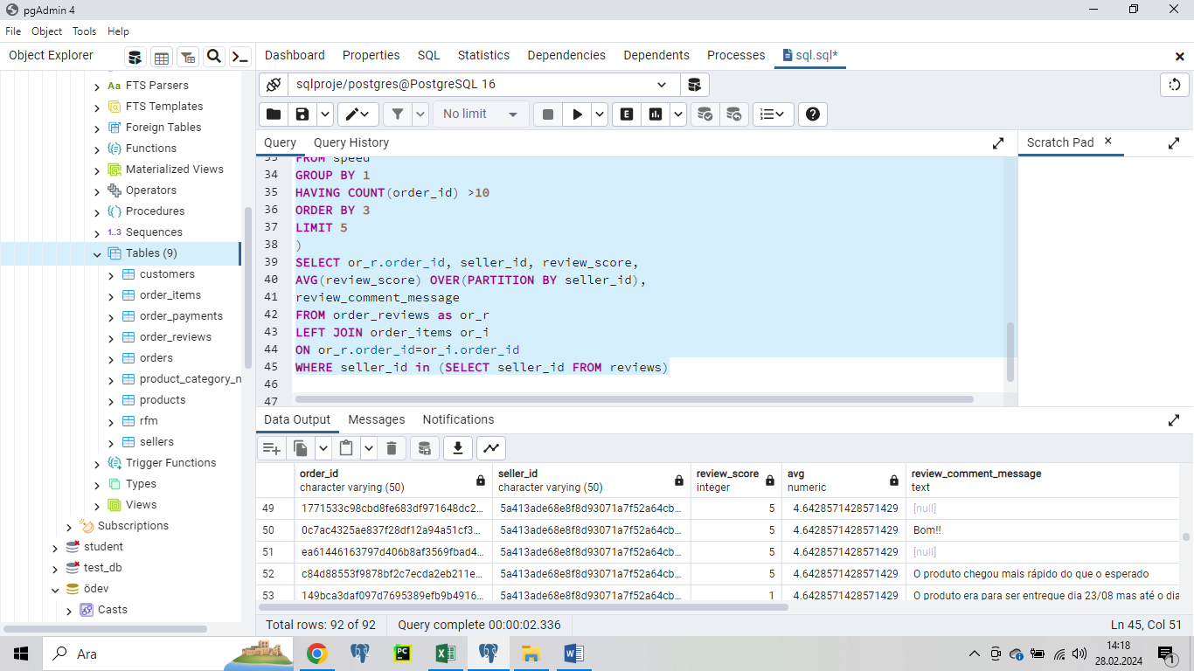

**Comment:** When the table resulting from this query is examined. The average score of the 5 fastest sellers is quite high, around 4.5. So customers are generally satisfied with the sellers.

Although customers' commenting preferences are not very high, customers who are dissatisfied and therefore give low scores prefer to write comments.

**2.Which sellers sell products from more categories?**

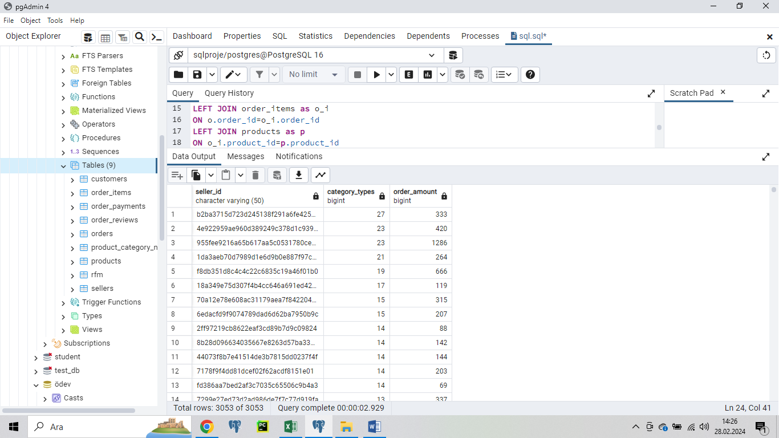

**Comment:** In this query, the sellers with the most category types and their total order numbers were queried. When the table is examined, it would not be correct to say that the seller with more categories also has more orders. While there are sellers who sell only 1 category and have hundreds of orders, there are also sellers whose number of categories is much higher than the others and whose total orders do not exceed 100. So, there is nothing directly proportional in this regard.

##### **PAYMENT ANALSIS**

**1. In which region do users with the highest number of installments live? (Considered customers who have more than 12 installments).**

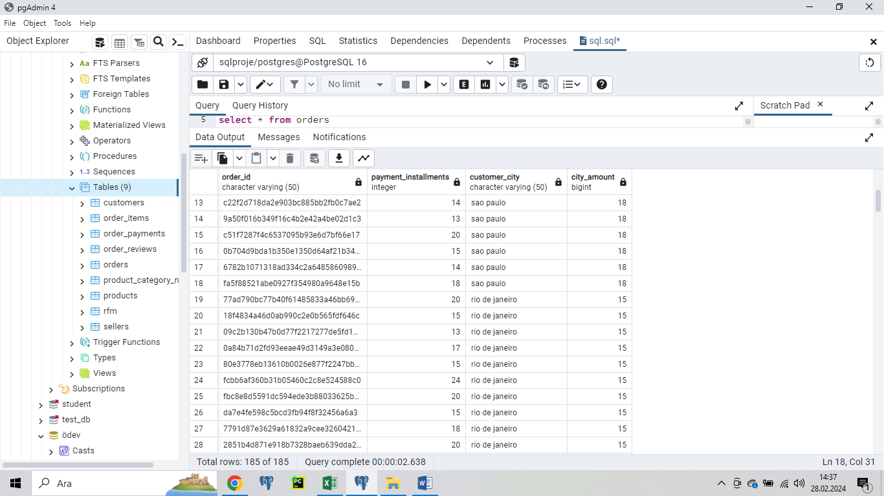

**Comment:** n this query, customers and cities who made excessive installments were questioned. Since the number of installments is relative, customers who made more than 12 installments were taken into consideration.

As expected, customers living in Sao Paulo and Rio De Janeiro, Brazil's two largest cities, make the most installment payments..

**2. Calculate the number of successful orders and total successful payment amount according to payment type. Rank them in order from the most used payment type to the least.**



**Comment:** The table shows the frequency of use, number of orders and total payment amount according to payment type. The most preferred payment type is Credit Card.

3**. Make a category-based analysis of orders paid in one shot and in installments. In which categories is payment in installments used most?**

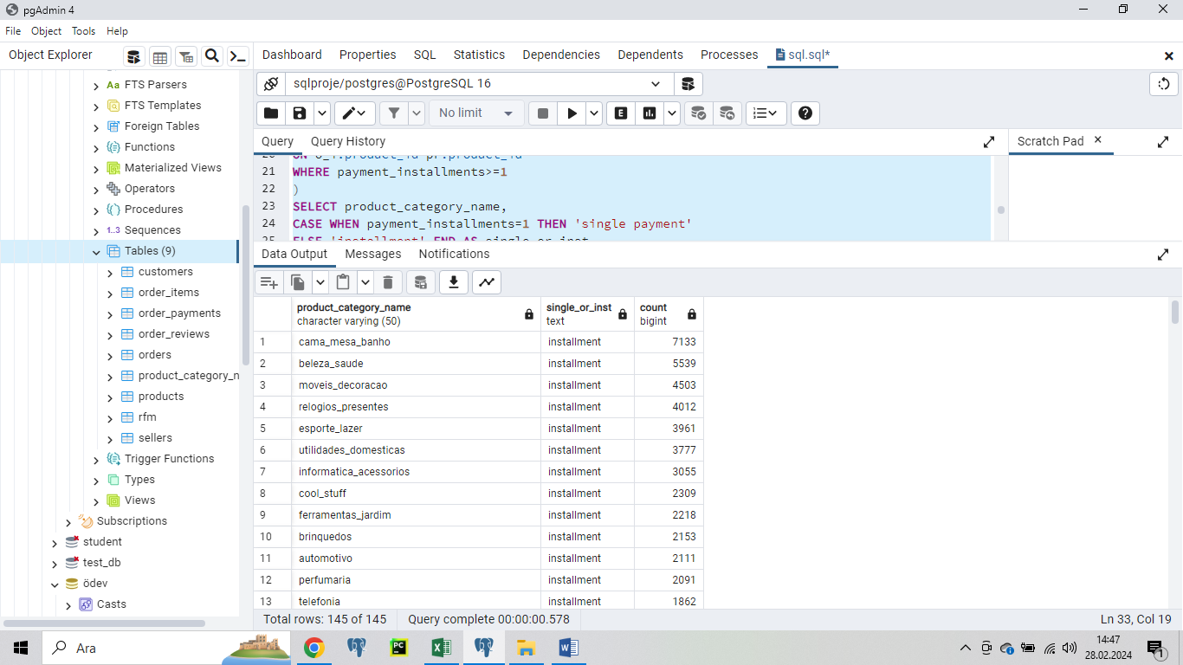

**Comment:** In the table, category-based installment sales and single-shot sales numbers are examined. Installment sales are more preferred for large products such as household goods, garden items and furniture.